**RSE2107A - Analysis and Selection between Alternative Solutions**

Introduction

* This document focuses on identifying a preferred solution that best meets the needs for our arena and robot behaviour within given constraints. Aligned with systems approach, it builds upon prior from Synthesizing Possible Solutions and evaluates them against key project requirements.
* Selected decisions are documented and justified. This will guide the next steps in implementing the system.

Assessment Criteria

* Resemblance to theme
* Overall aesthetics
* Successful navigation
* Workmanship
* Obstacle avoidance

Scoring Matrix for Terminal 3 Attractions

* Our team used a scoring matrix to evaluate each proposed element against our own set of criterias that are relevant to project goals. Each criteria was scored from a scale of 1 to 5, where 5 represents the best performance / accurate representation / provides meaning challenge or support whereas 1 represents the lowest.   
  They are:
* Resemblance (RE)
* Aesthetics (AE)
* Navigation Impact (NI)
* Space Efficiency (SP)
* Ease of Construction (EC)
* Cost (CO) — Higher Scoring = Cheaper the cost
* Technical Risk (TR) — Likelihood of failing
* Feasibility (FE) — how practical and achievable it is

| Elements | RE | AE | NI | SP | EC | CO | TR | FE | Total |
| --- | --- | --- | --- | --- | --- | --- | --- | --- | --- |
| Green Wall | 5 | 4 | 5 | 4 | 5 | 5 | 5 | 5 | 38 |
| Departure Gate | 5 | 4 | 5 | 4 | 4 | 5 | 5 | 5 | 37 |
| Daisy by Christian Moeller | 5 | 5 | 4 | 5 | 3 | 5 | 5 | 4 | 36 |
| Check-in Booths | 3 | 3 | 4 | 5 | 3 | 5 | 4 | 5 | 32 |
| Han Sai Por’s Flora Inspiration | 5 | 5 | 4 | 5 | 3 | 4 | 4 | 5 | 35 |
| Butterfly Garden | 5 | 5 | 2 | 1 | 1 | 2 | 3 | 3 | 22 |
| Crystal Garden | 4 | 5 | 2 | 1 | 1 | 2 | 3 | 3 | 21 |
| Skylight Roof System | 5 | 5 | 5 | 4 | 3 | 5 | 3 | 5 | 35 |
| Lee Wei Lieh's Lantern of Duty | 4 | 3 | 4 | 4 | 3 | 4 | 4 | 4 | 30 |

Scoring Matrix for Obstacles

* Our team used a scoring matrix to evaluate each proposed obstacle based on our own set of criteria that we defined to represent the level of difficulty for the LIMO bot. Each obstacle was rated 1 to 5, where 1 indicates low difficulty and 5 indicates high difficulty.  
  They are:
* Detectability
* Maneuver-ability
* Recovery stress

| Obstacle Type | Detectability  (LiDAR/vision) | Maneuver-ability  (path to get around or over) | Recovery Stress  (likelihood of triggering recovery) | Overall Difficulty  (avg. rounded) |
| --- | --- | --- | --- | --- |
| Low Hump | 4  (below the sensors) | 1  (slows bot, small pitch) | 2  (rarely fails) | 3 |
| Handrail | 2  (thin profile) | 3  (narrows corridor) | 3 | 3 |
| Boundary Barrier | 1  (big planar wall) | 4  (forces full replan) | 3 | 3 |
| Static Gantry | 3  (complex shape) | 3  (requires precise centering) | 3 | 3 |
| Conveyor Belt (Moving) | 5  (below the sensors) | 5  (forces constant localization) | 5 | 5 |
| Acrylic panels | 5  (LiDAR “Ghost” readings) | 2  (Flat, stationary) | 4 | 4 |

### 

### Arena Base Material

* To select a suitable base material for the arena floor, our team used a scoring matrix based on five criteria: feasibility, cost, visual representation, safety, and sensor compatibility. Each option was rated on a scale from 1 (poor) to 5 (excellent).
* This helped us evaluate the different trade-offs. The verdict column summarizes the strengths and limitations of each material, supporting a reasoned final selection based on our project constraints.

| Option | Feasibility | Cost | Visual Representation | Safety | Sensor Compatibility | Verdict |
| --- | --- | --- | --- | --- | --- | --- |
| Acrylic Sheet | 1 | 1 | 5 | 3 | 2 | Good premium look, but only if budget allows |
| Cardboard Sheet | 5 | 5 | 1 | 5 | 5 | Cheap and Easy, Low-quality looks |
| Coagulated Sheet | 5 | 5 | 4 | 5 | 5 | Affordable, Safe, easy to work with, |

### 

### Pathfinding Algorithms

* To select the most suitable pathfinder for our mixed-terrain, obstacle-rich arena, we applied a scoring matrix across five criteria: accuracy, speed, resource usage, adaptability, and tuning effort. Each algorithm was rated on a scale from 1 (poor) to 5 (excellent).
* This comparison highlights the trade-offs between always finding the shortest path, planning speed and resource use, and how well each handles unexpected obstacles, helping us choose the most suitable pathfinding algorithms.

| Criteria | Dijkstra | A* |
| --- | --- | --- |
| Accuracy | 5  Always finds the optimal path. | 5  Guarantees the shortest path by focusing on routes that lead most directly toward the goal. |
| Speed | 2  Slow, exhaustive search. | 5  Fast, because it quickly zeroes in on promising directions. |
| Resource Usage | 2  High, explores all nodes. | 4  More efficient, as it examines far fewer nodes to reach the destination. |
| Adaptability | 3  Works reliably in structured/static environments. | 4  Handles narrow passages and obstacle changes more smoothly. |
| Tuning | 5  Minimal tuning needed. | 2  Requires some tuning. |
| Verdict | 3  Reliable but too slow for a complex arena. | 5  Best fit; fast, efficient, adaptable for mixed-terrain and obstacles. |

* Although A* offers faster and more adaptability in complex arenas, our team chose Dijkstra’s algorithm due to its guaranteed optimality, simplicity, and reliability in environments where consistent performance is more critical than speed.
* This makes it a strong choice in environments where the terrain is too unpredictable for heuristic estimates to remain valid. The algorithm’s exhaustive search ensures that no possible path is overlooked, which is crucial in scenarios requiring reliable and complete navigation

### SLAM Options

* To select the most suitable SLAM solution for our mixed-terrain, obstacle-rich arena, we applied a scoring matrix across five criteria: mapping accuracy, speed, resource usage, terrain adaptability, and setup complexity. Each SLAM package was rated on a scale from 1 (poor) to 5 (excellent).
* This comparison highlights the trade-offs between map quality, computational demand, adaptability to varied surfaces, and ease of deployment, helping us choose the most robust SLAM approach for reliable, real-time navigation.

| Criteria | Gmapping | Cartographer | RTAB |
| --- | --- | --- | --- |
| Accuracy | 4  Good 2D mapping, some drift over time. | 5  High accuracy, real-time loop closure. | 5  Excellent, with graph optimization + loop closure |
| Speed | 4  Fast, efficient on small maps. | 4  Fast but CPU intensive on larger maps. | 3  Needs tuning;  heavier processing |
| Resource Usage | 4  Lightweight, minimal CPU. | 3  Medium-to-high CPU needs. | 3  High CPU/GPU |
| Terrain Adaptability | 3  Works best on flat, static areas. | 4  Adapts better to dynamic or looped layouts. | 5  Best at handling varied environments, height changes, and complex layouts with rich data fusion. |
| Ease of Setup | 5  Simple, ROS standard. | 3  Needs more parameter tuning. | 3  More complex to set up, but powerful once configured. |
| Verdict | 4  Reliable baseline for simple arenas. | 4.5  Strong all-around choice if tuned. | 5  Best long-term solution for mixed terrain; invest in setup to unlock top performance. |

LIMO bot

* To choose the best wheel configuration for our high-hump, obstacle-rich arena, we listed each mode’s key strengths and weaknesses and assigned a suitability score from 1 (poor) to 5 (excellent).
* This highlights the trade-offs between traction on uneven surfaces, maneuverability in tight spaces, odometry reliability, and tuning effort, helping us select the optimal drive configuration for reliable, real-time navigation.

| Configuration | Strengths | Weaknesses / Risks | Suitability Score |
| --- | --- | --- | --- |
| Differential Drive | Simple to control; stable on flat surfaces; easy odometry tuning | Struggles on high humps; risk of wheel slip or grounding; no extra traction support | 2 |
| Ackermann Steering | Handles gradual slopes or ramps well; realistic car-like movement | Large turning radius; weak on steep humps; cannot strafe or pivot | 1 |
| Omni-directional (Mecanum) | Can sidestep obstacles; agile in flat, open layouts | Poor traction on uneven/high humps; mecanum rollers can slip badly | 1 |
| Tracked | High grip; can crawl over humps; weight spread reduces ground pressure | Causes odometry slip (skidding); rougher SLAM tuning; higher mechanical stress | 4 |

### Final Selection Choices

* This section summarizes the final components selected for implementation based on scoring matrices, team discussions, and system requirements. Each selection reflects careful consideration based on the scoring matrix earlier. This ensures our team remains within the defined scope while supporting autonomous performance.
* Arena Theme
  + Terminal 3 Departure Hall
* Arena Base
  + Coagulated Sheet
* Elements
  + Terminal Shell
  + Skylight Roof System
  + Green Wall
  + Daisy
  + Floral Inspirations
  + Airline Counters
* Obstacles
  + Low Humps
  + Acrylic Panels
  + Static Gantry
  + Boundary Barriers
* LIMO bot
  + Tracked
  + RTAB-Map
  + DWA planner
  + Dijkstra

Supporting Artifacts- Full Arena Layout

* The strategy in mind is to simulate a realistic segment of Terminal 3 based on the final selection choices listed earlier. Surrounding the center terminal shell is a designated path for navigation, slowly leading to the terminal entrance. Boundary barriers are placed strategically to prevent collisions from the central structure. Ends of the path are blocked by static gantry.
* As the LIMO bot progresses, it will enter the terminal shell structure, which represents the interior of Terminal 3. This transition allows the LIMO to experience both outdoor and indoor navigation. Our outdoor path includes minor obstacles such as small humps to simulate uneven terrain and to test motion stability. Then as it enters the terminal shell, there will be surrounding elements to act as dead ends to guide the path of the LIMO to trigger autonomous recovery behaviours.

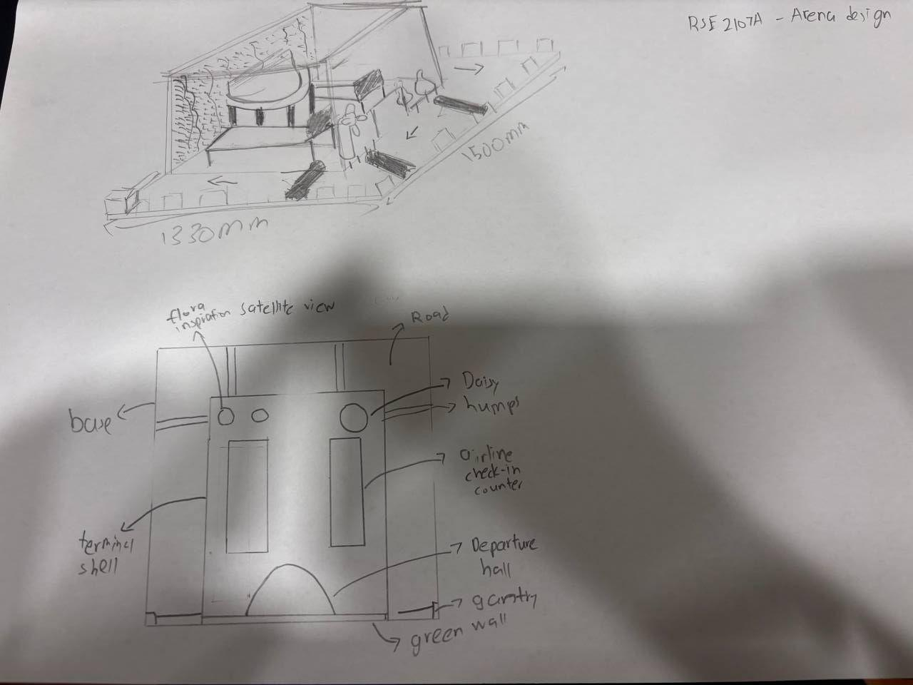

Supporting Artifact- Floral Inspirations

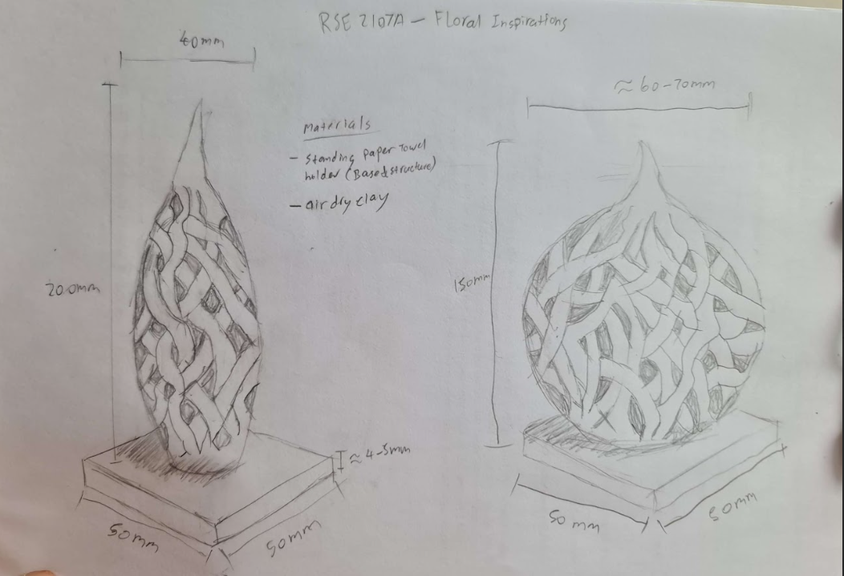

Supporting Artifact- Departure Gate

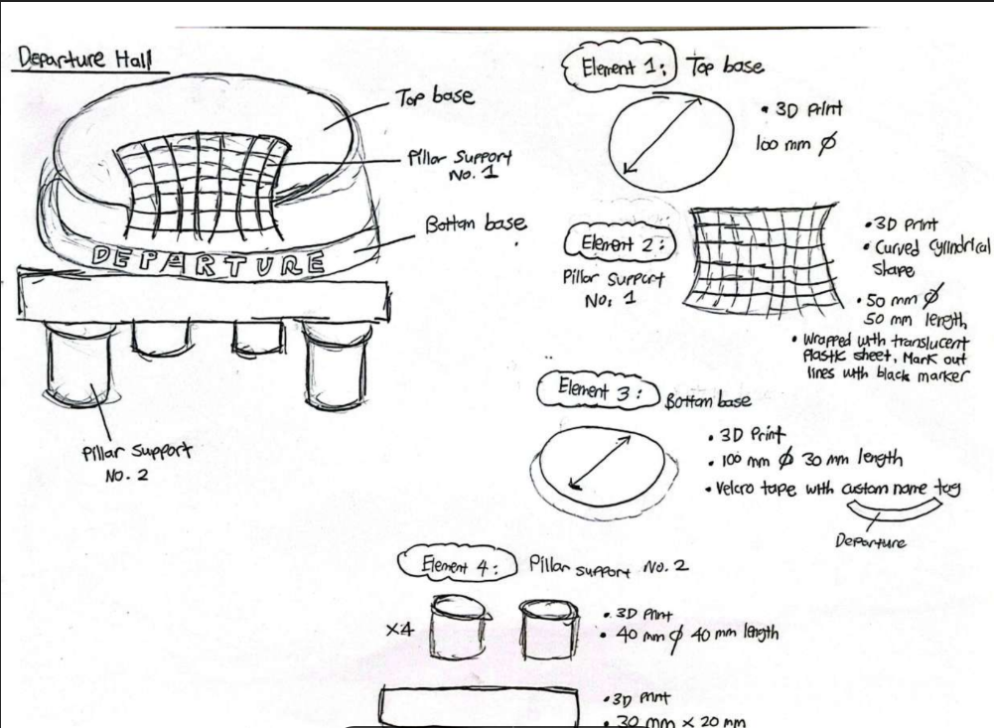

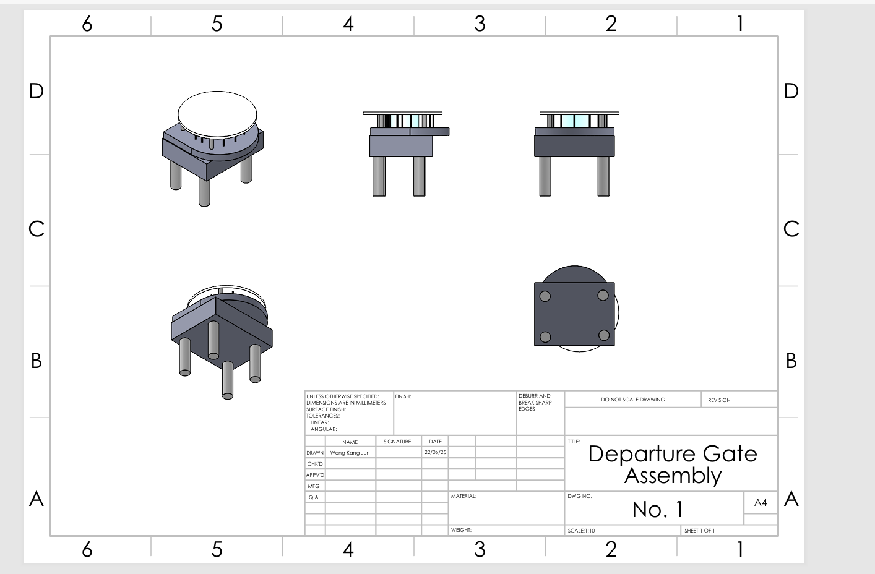

Supporting Artifact- Daisy

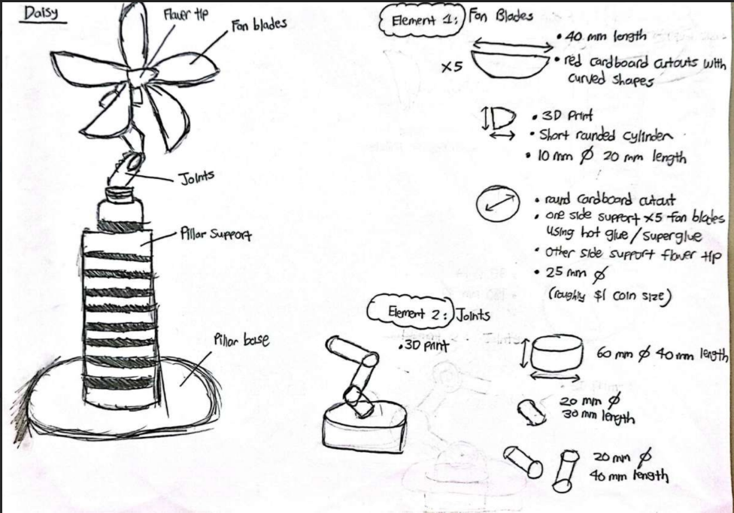

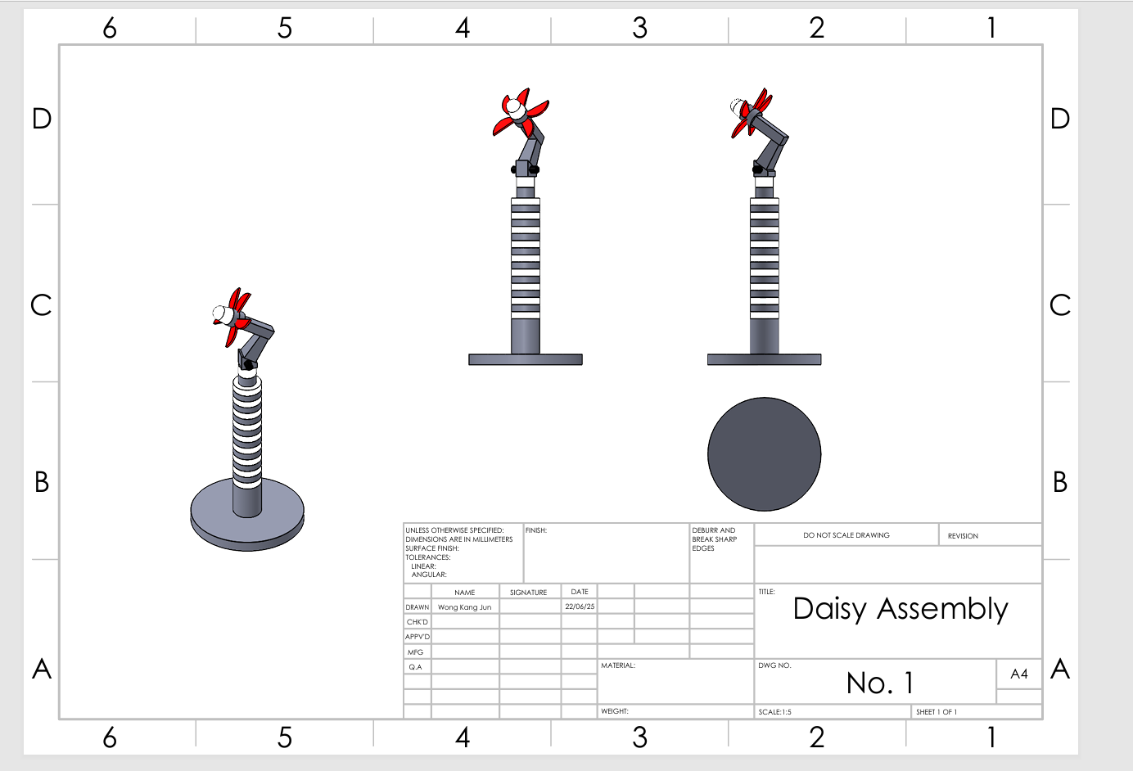

Supporting Artifacts- Low Humps, Static Gantry, Boundary Barriers

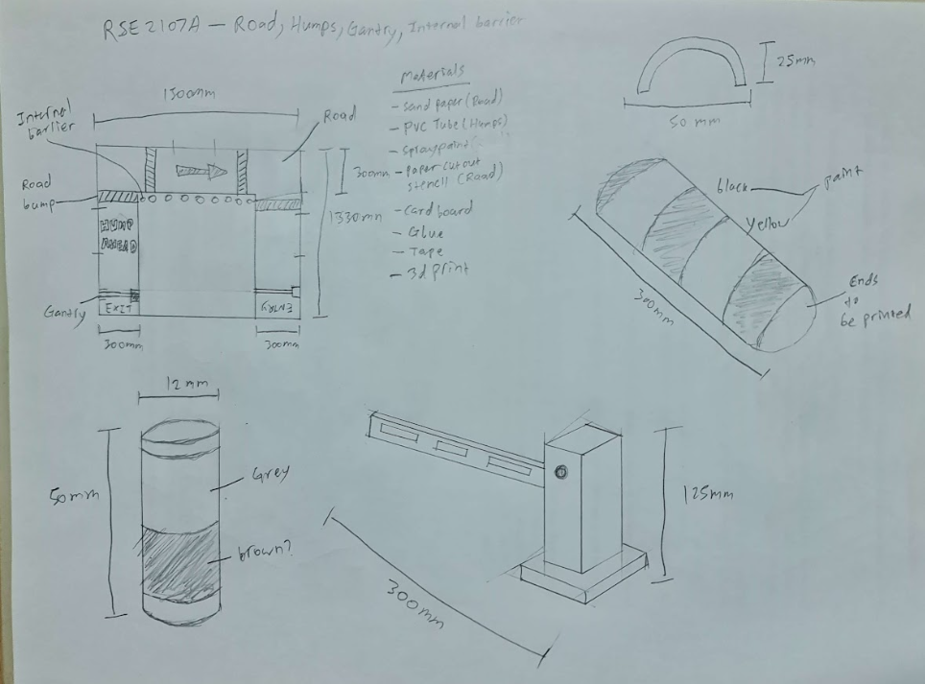

Supporting Artifacts- Airline Counters

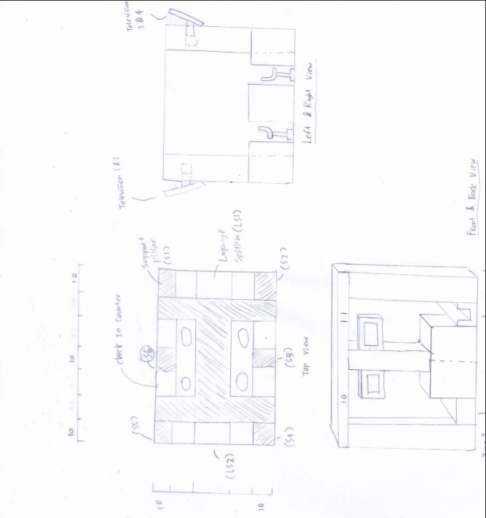

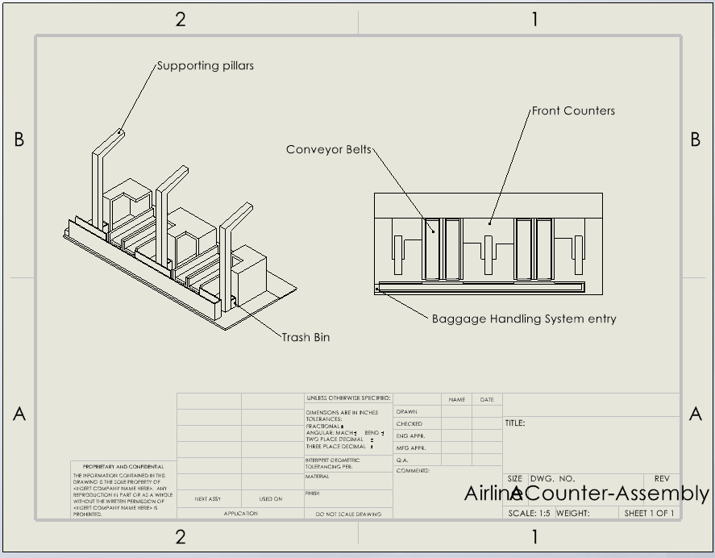

Supporting Artifacts- Terminal Shell, Skylight Roof System

* Acrylic was chosen for the terminal shell. Why acrylic? Our team chose this as we felt it serves as a clean finish to build a visually and modular layout of the terminal 3 building. It represents transparent or glass-like structures commonly found in real-world indoor settings. The acrylic terminal shell also acts as an obstacle for the opposing LIMO so if their LIDAR parameters are not properly tuned, they are likely to collide with it.
* However, our team was aware that clear materials can interfere with LiDAR, so to mitigate this, we implemented external barriers made from PVC around the acrylic structure. These serve as physical markers that are easily detected by LiDAR, ensuring that the LIMO perceives boundaries correctly even when the underlying acrylic is not LiDAR-reflective.

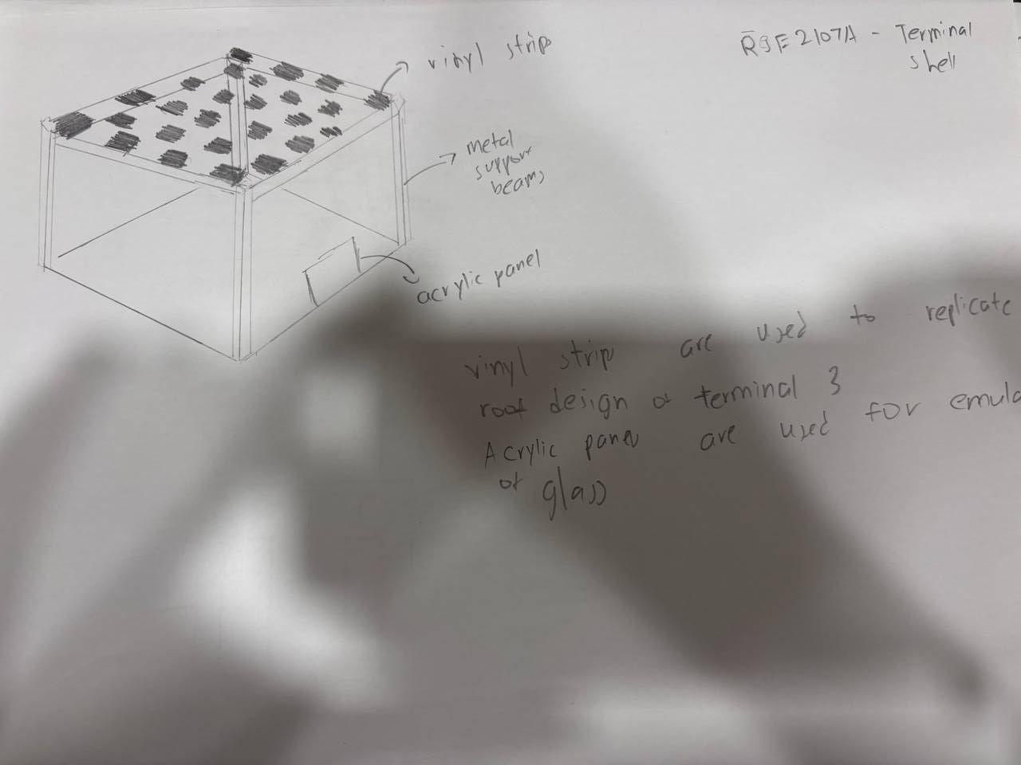

Supporting Artifacts- Foam Sheet (Arena Base)

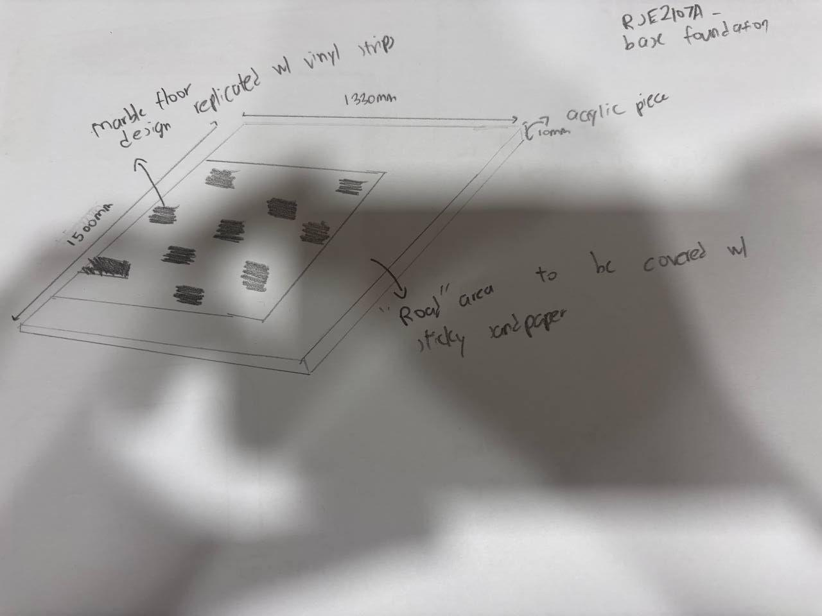

Supporting Artifacts- Green Wall

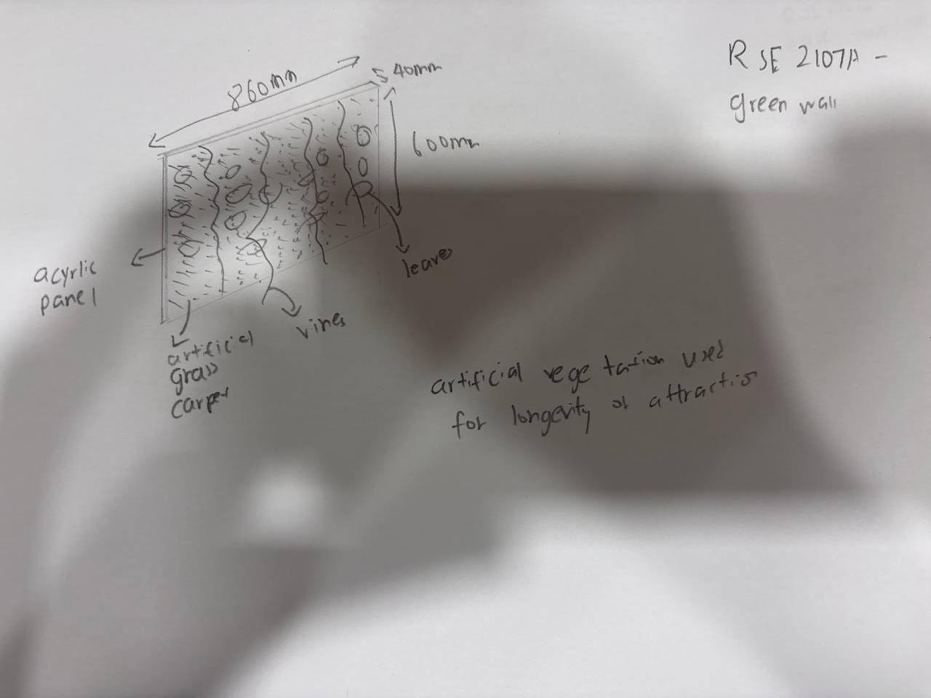

Supporting Artifacts- Acrylic Panels

